**Designing a soldering station**

|  |  |
| --- | --- |
| Author | Brent Gerets |

Content

1 Introduction 1

2 Material and methods 2

2.1 Materials 2

2.2 Methods 3

3 Results 6

3.1 Functionality 6

3.2 Schematic design 6

3.2.1 Elektor 6

3.2.2 Modifications 7

3.3 PCB design 10

3.3.1 Placing 10

3.3.2 Routing 11

3.4 Mechanical design 11

4 Discussion 14

5 Reference list 14

# Introduction

The goal of this project is to build a high quality soldering station for a reasonable price. The station consist of a 3D-printed case and a custom designed and built PCB. Three different high quality soldering irons can be used interchangeably for maximum ease of use. An article from the electronics magazine Elektor is used as a starting point. The schematics are used almost completely as is. Whereas the case design, PCB design, as well as some other small points, defer from the original. The materials, methods and results will be discussed in this application note, alongside a reflection on the project.

# Material and methods

## Materials

A variety of standard electronics components are used in the project and had to be ordered at a number of different suppliers. Mouser was chosen as the preferred supplier in an attempt to order as many components as possible from the same supplier. This makes the process of ordering and receiving the components easier. The reasoning behind choosing Mouser is that they also operate in Europe, making shipping faster and less expensive. However, a small amount components had to be ordered from different suppliers since they were not available at Mouser. The table below contains the bill of materials which shows the quantity, supplier, price and delivery date of every component. The table is split into three parts, wherein the top part concerns the main functionality of the station, and the middle part concerns the functionality of the display. The order information of the PCB is located at the bottom.

|  |  |  |  |  |  |
| --- | --- | --- | --- | --- | --- |
| **Item** | **Quantity** | **Supplier** | **Unit Price (€)** | **Total Price (€)** | **Delivery Date** |
| Main | | | | |  |
| 18kΩ resistor | 3 | Mouser | 0.091 | 0.273 | 11/05/2022 |
| 1MΩ resistor | 1 | Mouser | 0.118 | 0.118 | 11/05/2022 |
| 68kΩ resistor | 1 | Mouser | 0.091 | 0.091 | 11/05/2022 |
| 5.6kΩ resistor | 4 | Mouser | 0.091 | 0.364 | 11/05/2022 |
| 10kΩ resistor | 3 | Mouser | 0.091 | 0.273 | 11/05/2022 |
| 100Ω resistor | 3 | Mouser | 0.091 | 0.273 | 11/05/2022 |
| 10MΩ resistor | 1 | Mouser | 0.091 | 0.091 | 11/05/2022 |
| 4.7kΩ resistor | 6 | Mouser | 0.091 | 0.546 | 11/05/2022 |
| 10μH 130mA choke coil | 1 | Mouser | 0.3 | 0.3 | 11/05/2022 |
| 10A common mode choke coil | 1 | Mouser | 1.52 | 1.52 | 11/05/2022 |
| 4700μF 50V capacitor | 1 | Mouser | 3.08 | 3.08 | 11/05/2022 |
| 10μF 50V capacitor | 3 | Mouser | 0.237 | 0.711 | 11/05/2022 |
| 100nF (0.1μF) 50V X7R capacitor | 5 | Mouser | 0.218 | 1.09 | 11/05/2022 |
| 100μF 50V capacitor | 1 | Mouser | 0.246 | 0.246 | 11/05/2022 |
| 10nF (0.01μF) 50V X7R capacitor | 4 | Mouser | 0.309 | 1.236 | 11/05/2022 |
| 1N4007 rectifier diode | 1 | Conrad | 0.08 | 0.08 | 09/05/2022 |
| 1N5321B zener diode | 1 | Mouser | 0.155 | 0.155 | 11/05/2022 |
| 1N4148 diode | 1 | Mouser | 0.091 | 0.091 | 11/05/2022 |
| 600V 6A bridge rectifier | 2 | Mouser | 2.07 | 4.14 | 11/05/2022 |
| BC547C transitor | 3 | Conrad | 0.04 | 0.12 | 09/05/2022 |
| IRF9Z34NPBF mosfet | 1 | Mouser | 0.91 | 0.91 | 11/05/2022 |
| BC557C transistor | 1 | Conrad | 0.17 | 0.17 | 09/05/2022 |
| 5V 1.5A DC DC converter | 1 | Mouser | 1.8 | 1.8 | 11/05/2022 |
| MCP6002-E/P dual-opamp | 1 | Mouser | 0.482 | 0.482 | 11/05/2022 |
| ATMEGA4809-PF MCU | 1 | LCSC | 5.28 | 5.28 | 16/05/2022 |
| RT424005 relay | 1 | Mouser | 4.2 | 4.2 | 11/05/2022 |
| MKDSN 1,5/2-5,08 terminal block | 4 | Conrad | 0.59 | 2.36 | 09/05/2022 |
| 4-103321-8 pinheader | 2 | Mouser | 2.63 | 5.26 | 11/05/2022 |
| 4-103322-2 pinheader | 1 | Mouser | 3.6 | 3.6 | 11/05/2022 |
| toroidal transformer, 60VA 230V 12V | 1 | TME | 22.8 | 22.8 | 16/05/2022 |
| K & B 59JR101-1FR-LR IEC connector | 1 | Conrad | 9.19 | 9.19 | 09/05/2022 |
| Soldering iron connector | 1 | AliExpress | 1.76 | 1.76 | 24/05/2020 |
| Display | | | | |  |
| 10kΩ resistor | 3 | Mouser | 0.091 | 0.273 | 11/05/2022 |
| 4-digit display module | 1 | Mouser | 3.9 | 3.9 | 11/05/2022 |
| 100μF 50V capacitor | 1 | Mouser | 0.246 | 0.246 | 11/05/2022 |
| 100nF (0.1μF) 50V X7R capacitor | 1 | Mouser | 0.218 | 0.218 | 11/05/2022 |
| 10nF (0.01μF) 50V X7R capacitor | 3 | Mouser | 0.309 | 0.927 | 11/05/2022 |
| PEC11R-4225F-S0024 encoder | 1 | Mouser | 1.53 | 1.53 | 11/05/2022 |
| Other | | | | | |
| PCB | 1 | JLCPCB | 1.9 | 1.9 | 16/05/2022 |
| Total | | | | 84.073 |  |

Tabel 1: Bill of materials

The choices of components were compared according to price and availability, as well as how close they are to the original design. To the extent of the latter, through hole components were preferred over SMD components. The reason for staying close to the original design is to reduce possible problems down the line.

Altium Designer is used to design the schematics and PCB since it is the software that is taught in this course.

## Methods

The first part in the process is also immediately the most unique and time consuming part, which is sourcing the components. This step requires a lot of comparing of products and searching for harder to find components. In this part of the process the Altium library is built up which contains schematic models, footprints and possibly 3D models for all the components. This is a very important step since the library will be used throughout the rest of the design process.

Figure 1: Part one of the design process: finding components

All the remaining parts of the process are pretty similar in that they all consist of a few broad steps, followed by a test-and-fix loop before leading to the next part. The second part consists of the creation of the schematics, in which the original design from Elektor is largely copied. However, the schematic is first separated into a few logical parts called ‘rooms’. Not only do these make the schematics more organized, they also come in handy in the PCB design step.

Figure 2: Part two of the design process: creating schematics

In the next part the PCB is designed by placing and routing the components. In this step the benefits of separating the schematic are reaped since the components are nicely grouped by schematic. This makes it easier to place the right components in close proximity of each other on the PCB.

Figure 3: Part three of the design process: creating the PCB design

After designing the PCB it has to be ordered. By the time the PCB has arrived the components have as well, which allows for the placing and soldering of components on the PCB. This part requires the most extensive testing since it concerns the main functionality of the soldering station.

Figure 4: Part four of the design process: creating the PCB

In the last part of the design process the case is designed, 3D-printed and assembled. This is followed by a final testing phase to verify that the completed soldering station works. The case design step largely runs parallel to the PCB creation step. They are displayed sequentially to preserve clarity.

Figure 5: Part five of the design process: case design and assembly

# Results

## Functionality

Unfortunately the soldering station was not done in time for the deadline of this application note. Everything is technically completed but could not be fully tested due to a lack of a soldering iron to test with and a lack of time. However, since the soldering station was largely copied from Elektor magazine it is still possible to explain the functionality.

The user flips the switch on the back of the soldering station to turn it on. When using it for the first time, the rotary encoder button on top must be held while the station starts to go into the configuration menu which can be seen on the display. Here, one of three soldering irons can be selected by turning the rotary encoder and pushing down for ten seconds. Afterward the rotary encoder can be used to adjust the desired temperature during which the display is at maximum brightness. If the rotary encoder is not used for five seconds, the temperature is set and the display is dimmed. While adjusting the temperature the display will show that temperature. Contrarily, when a temperature has been set, the real temperature of the soldering iron is shown. [1]

## Schematic design

### Elektor

An article from electronics magazine Elektor was used as a starting point for the project, including the schematic design. In this article the schematic design is split into two parts: the main schematic (Figure 6) and the display schematic (Figure 7). The reason for this is that this design consists of two PCB’s, one for each schematic. The main schematic can be split into four parts. The top left is responsible for providing a stable 5V and 12V to the rest of the circuit. The top right is the part that heats up the soldering iron. On the bottom right is an amplifier to amplify the signal from the temperature sensor in the soldering iron. And lastly the processor is located in the bottom left.

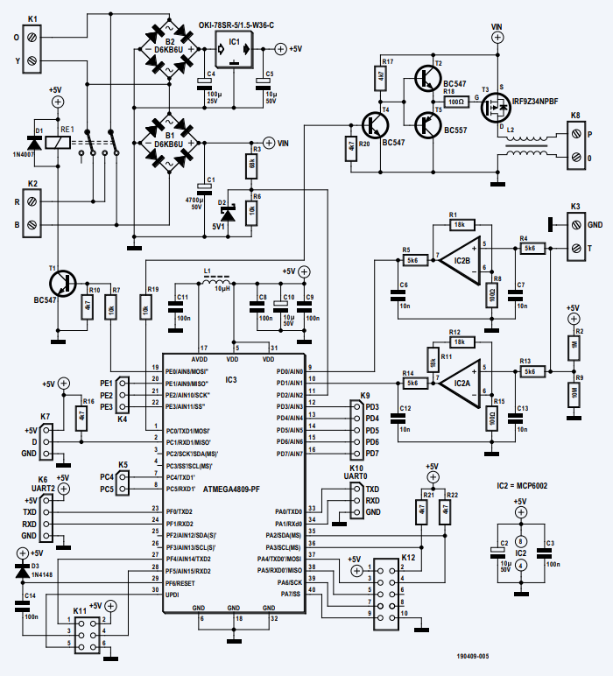

Figure 6: Main schematic from Elektor

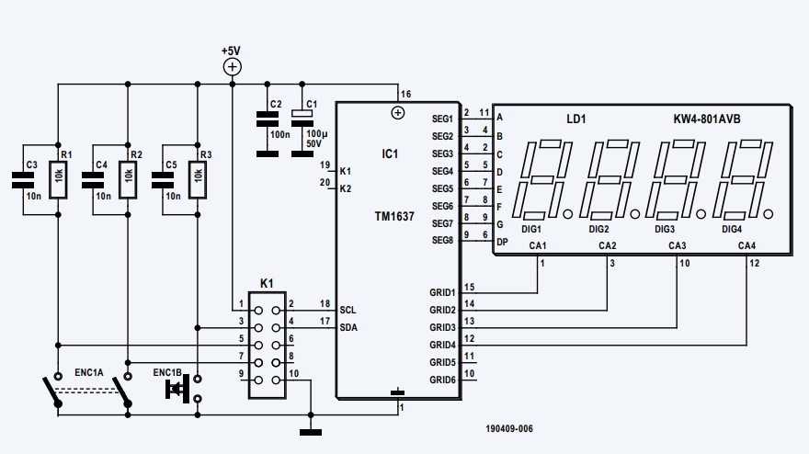

Figure 7: Display schematic from Elektor

### Modifications

As discussed in section 2.2, the main schematic was split into rooms for better organization. The rooms are simply the parts referred to in the previous subsection: power (Figure 8), heating (Figure 9), amplification (Figure 10) and processor (Figure 11). The display schematic (Figure 12) was also slightly simplified due to the use of a display module which already contains most necessary components. The rotary encoder was also not included in the display schematic since it is not placed on the PCB but rather connected with cables the one of the headers.

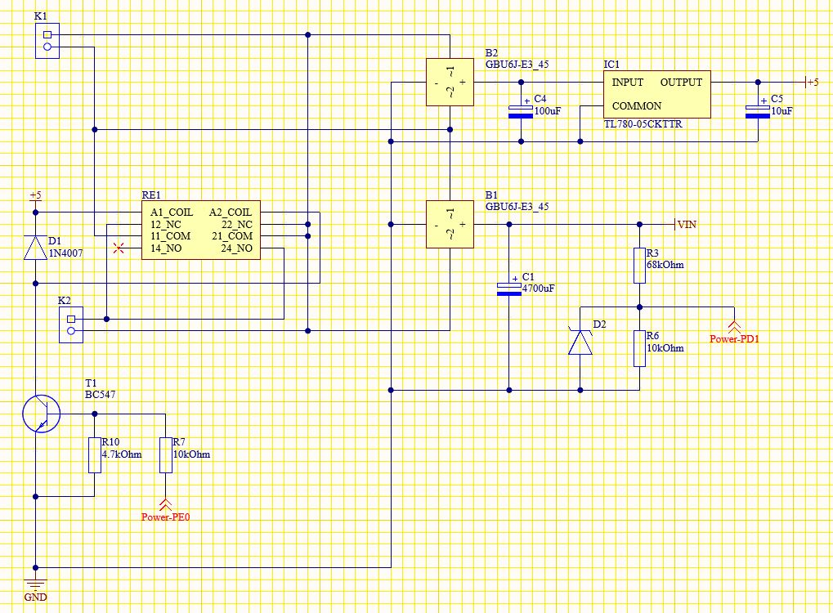

Figure 8: Power schematic

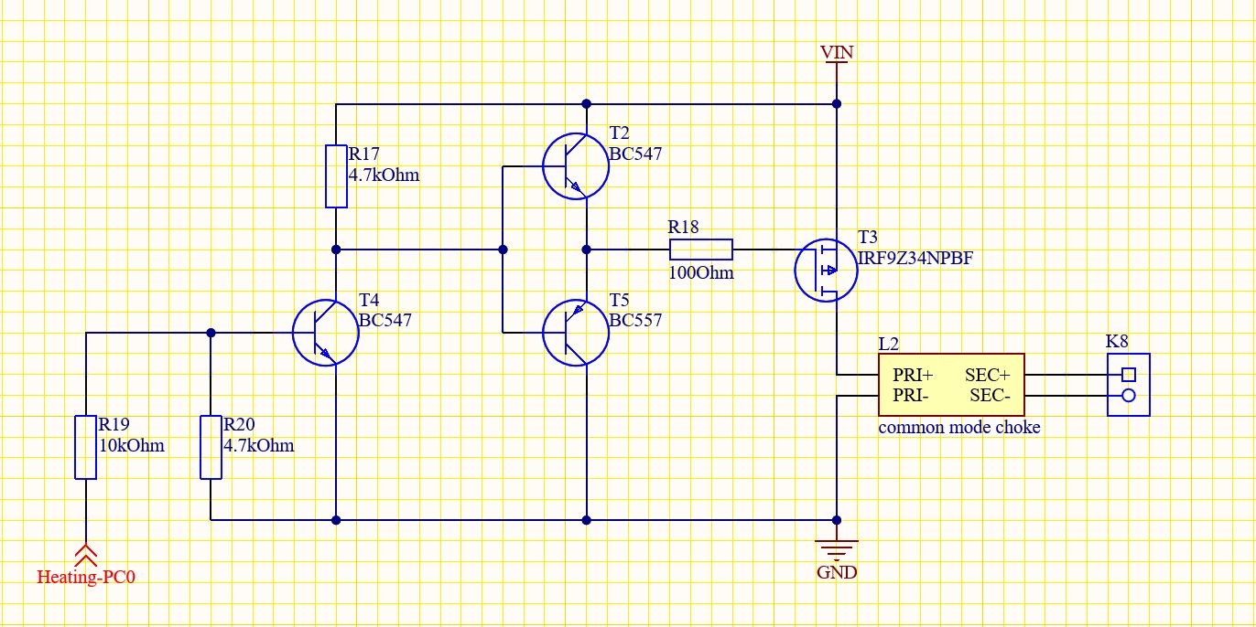

Figure 9: Heating schematic

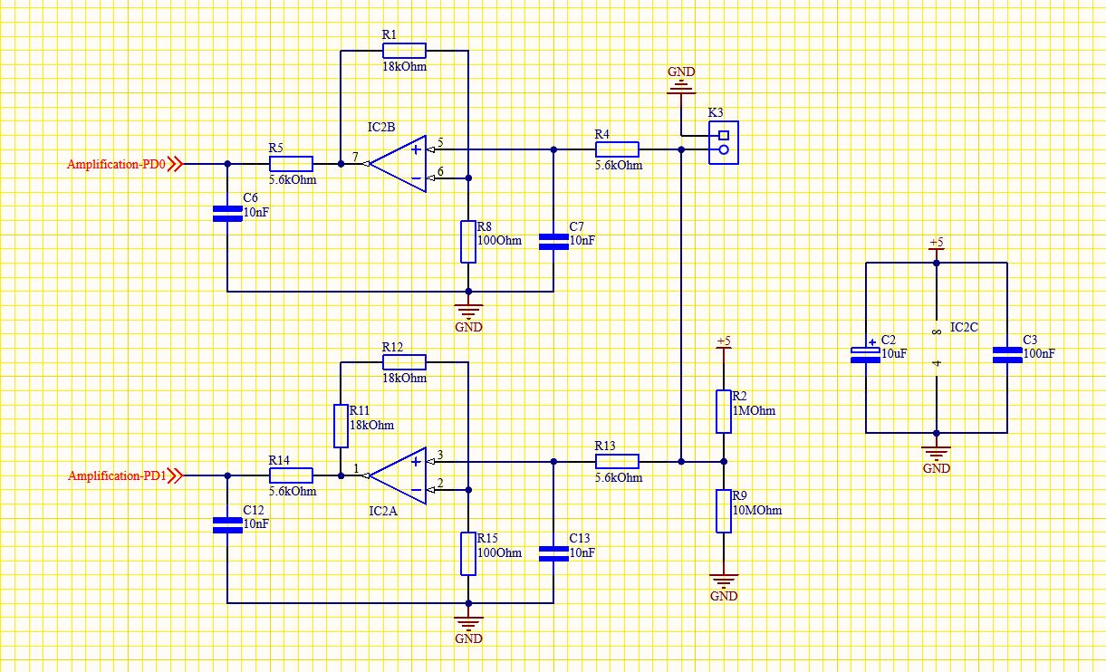

Figure 10: Amplification schematic

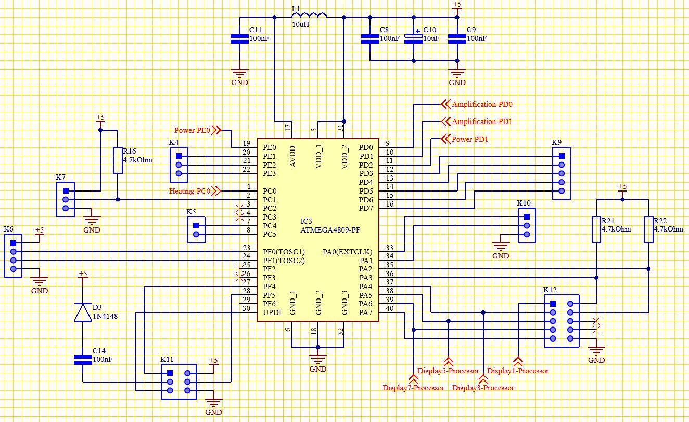

Figure 11: Processor schematic

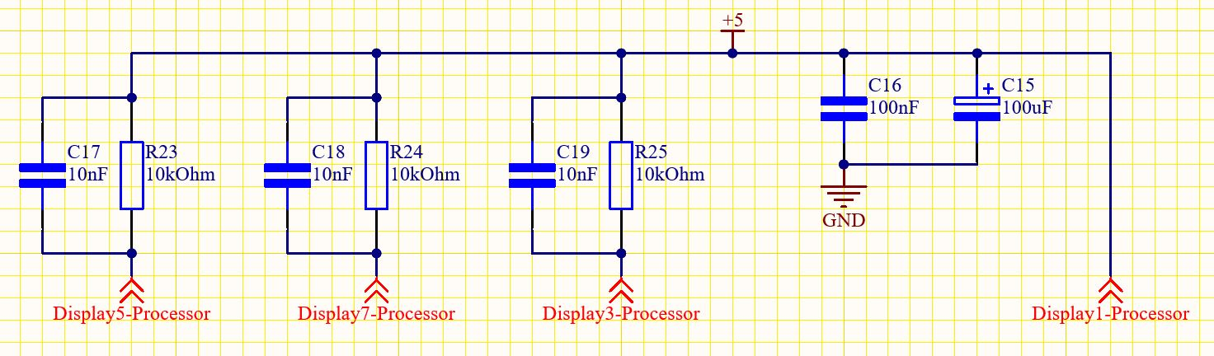

Figure 12: Display schematic

## PCB design

### Placing

The components were placed on the PCB (Figure 13) in a way that mostly preserves the groupings that were made in the schematic design. By doing this, most of the routes between components are shorter than if they were placed at random. The processor was placed in the centre since all the other parts need to be connected to it. The power group is located at the bottom, mostly below the processor. The display group is on the top right, amplification on the top-left, and heating in the middle to the left.

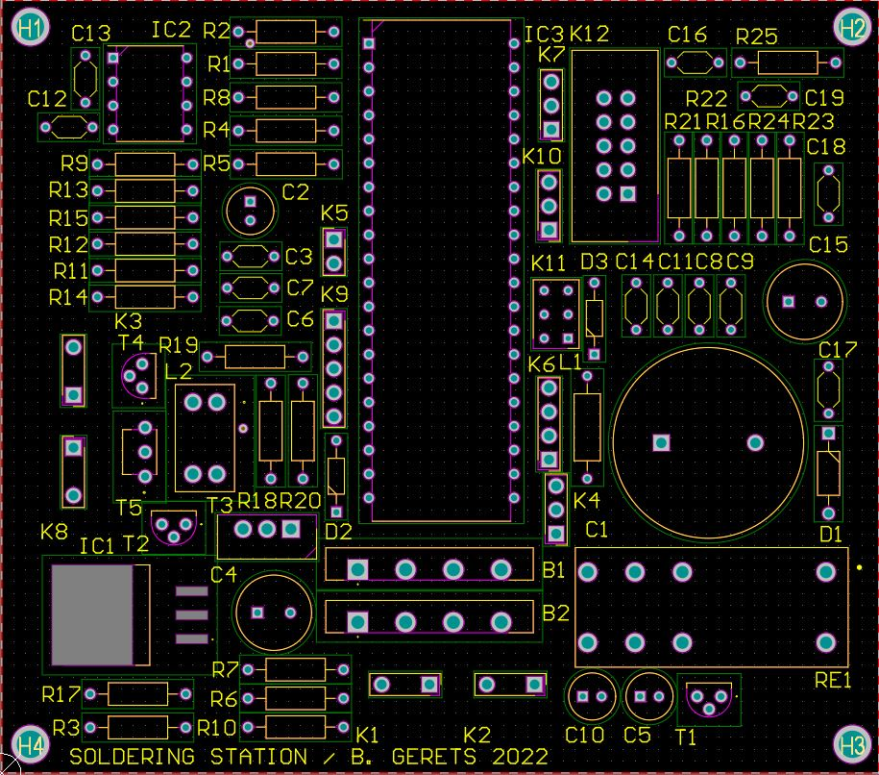

Figure 13: PCB design

### Routing

Routing was done automatically by Altium, with some minor adjustments done manually to increase the track width of the power circuit and remove some 90 degree track angles (Figure 14).

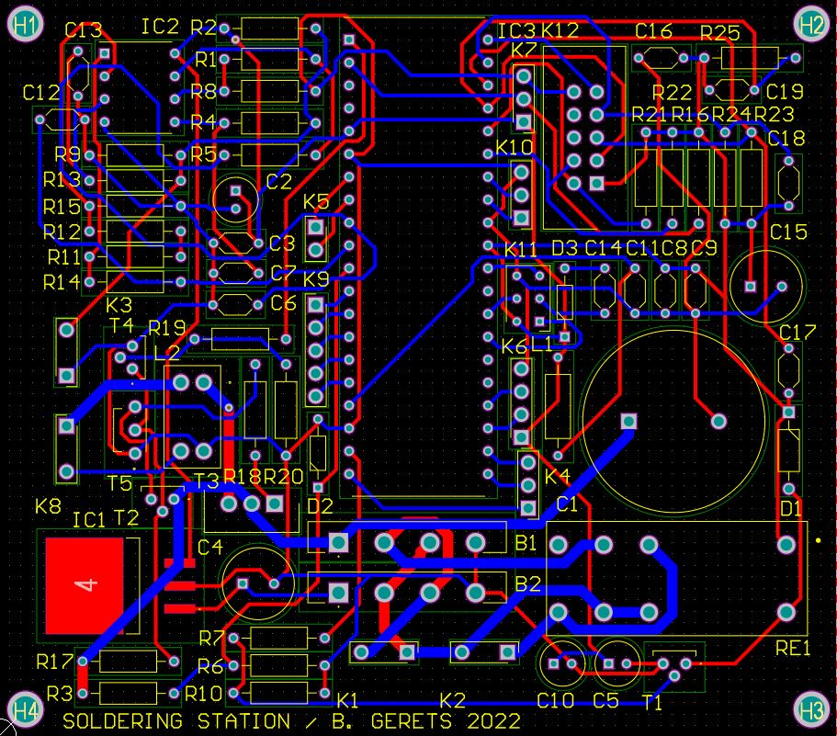

Figure 14: PCB design with routing (ground polygons removed for clarity)

## Mechanical design

The mechanical design consists mainly of two parts for ease of assembly and possibly also disassembly. The back part holds the PCB, transformer and IEC connector. The front part contains the rotary encoder, display, connector for the soldering iron and a hole to insert a soldering iron holder. In addition to this there are a few ventilation slats. Nuts were inserted and fastened into the front part to enable bolts to come through the back and join both parts.

The design was inspired by an old-school gas pump (Figure 15) and is therefore vertical in shape. The knob on the rotary encoder is also part of this design. Similarly, there are a few decorative parts to complete the look.

The mechanical design can be seen in Figure 16, the final product (without soldering iron) is shown in Figure 17. Figure 18 shows what the final product looks like when the case is opened.

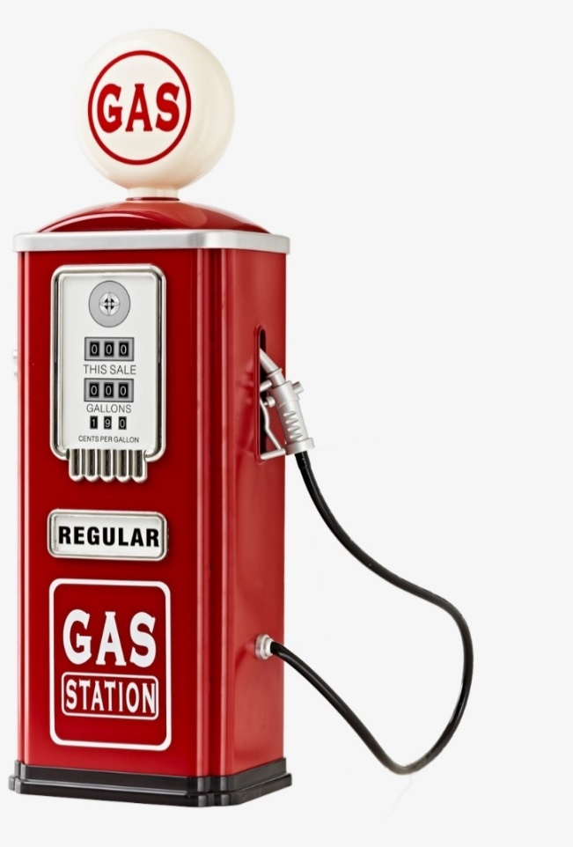

Figure 15: Inspiration for the mechanical design

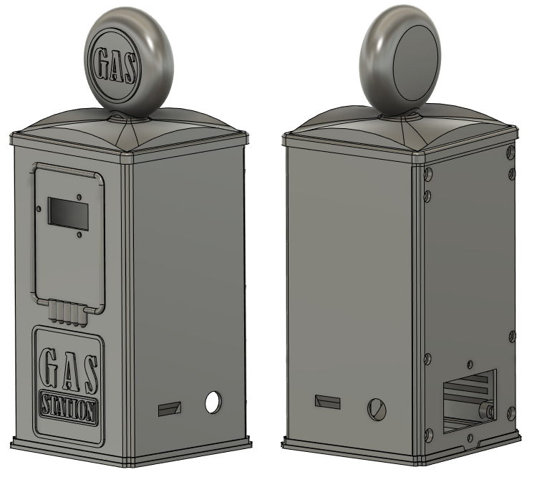

Figure 16: The mechanical design

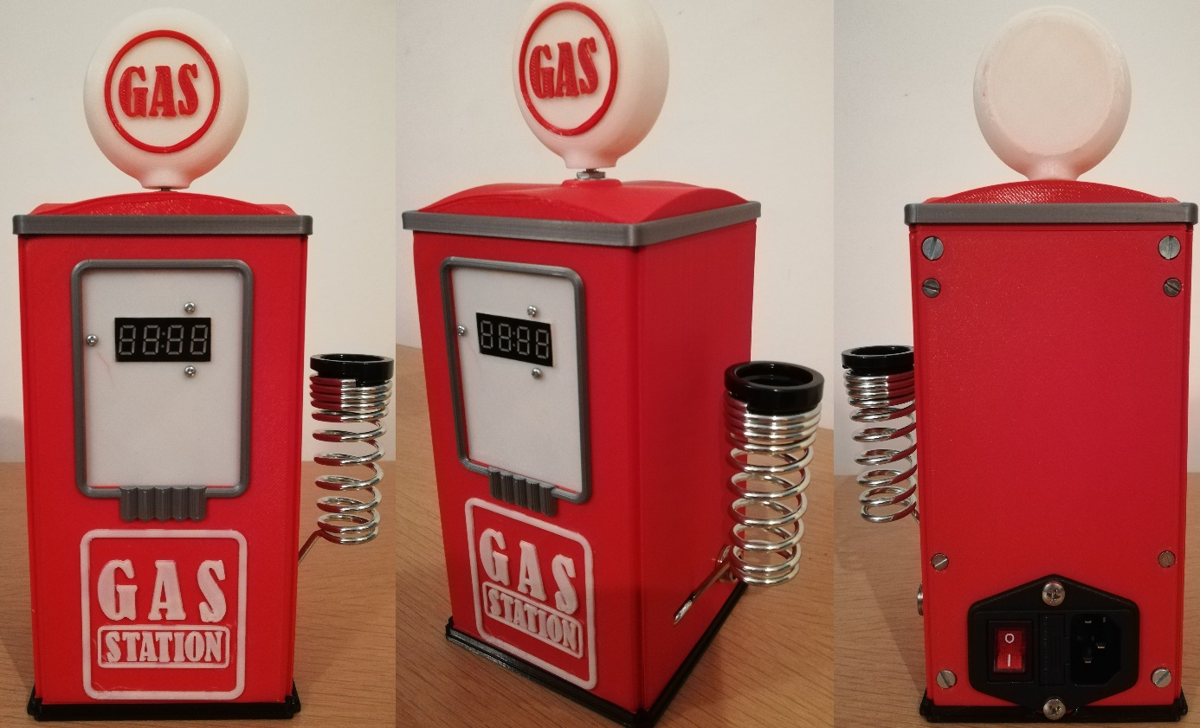

Figure 17: The final product

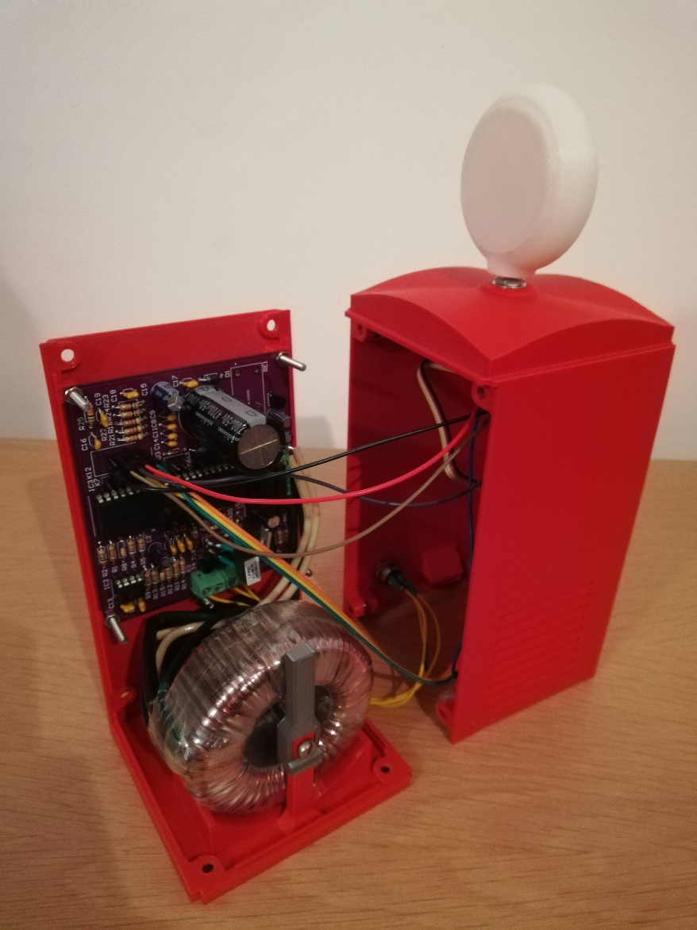

Figure 18: The final product, case opened

# Discussion

One issue that came up a few times during the component sourcing phase was certain components being unavailable. This meant a suitable replacement had to be found, which wasn’t too difficult but at the same time it increases the possibility of a mistake in the final product. The only thing that was able to be done to solve this issue is to exercise a lot of care when searching for a replacement.

During the PCB creation phase there was a small issue where the PCB design had an incorrect footprint where two of the three holes where swapped. This was solved by simply bending the legs on the component so they would be in the correct position. Similarly the common mode choke coil also had an incorrect footprint. This was solved by raising it off of the PCB and connecting it with cables.

The biggest issue encountered was the lack of time near the end of the project. This being partly self-inflicted due to leaving some parts of the project too long. However, also partly due to the project being a series of steps where one can only be started once the previous has finished. At times this made it impossible to work on the project due to for example waiting for components to arrive or waiting for the lecture on the next step. Next time the project will certainly not be left as much and components will be ordered as soon as possible.

During the PCB creation phase, the power circuit was tested and everything worked as it should. However, after rewiring the common mode choke coil the relay started rapidly turning on and off. An attempt was made to resolve this issue by rewiring the relay but this was ultimately in vain. This problem will be further investigated in the next semester.

# Reference list

|  |  |
| --- | --- |
| [1] | L. Lemmens and M. Claussen, “Soldeerstation 2021,” *Elektor,* no. 665, pp. 30-36, 2021. |